
Boomerangs Minutes
  - Mayfield Boomerangs Baseball Club
Date | time 09/09/2020 7:35 PM |Meeting called to order by John Mossop

In Attendance
Attendees: John Mossop (President), Jason Picot (Snr-Vice President), Joshua Voigt (Secretary), Ann Voigt (Treasurer), Chris Jordan, Richard Campbell, Robert Voigt
Apologies: Stephen Petherbridge (Vice President), Virginia Petherbridge

Approval of Minutes
The minutes from the 05/08/2020 were read and accepted.
Moved Josh, Seconded Ann

Business Arising from Previous Minutes
- John got quotes for a new mower:
  - Softball is keen to go halves in the process
  - John needs to talk to Garry Hughes for softball’s final decision
  - Need to ensure the mower can handle the towing capacity of the roller/trailer.
  - Need to discuss the summer mowing of the baseball field with softball so we don’t receive the ground in poor quality.
  - Need to work from a Logbook and hours correspond to percentage of cost.
  - Will need to put a bit of an agreement together to send to softball.
- Custom Drink Bottles/Coffee mugs from Jane Frank was not chased up.
- Risk Assessment was submitted

Correspondence
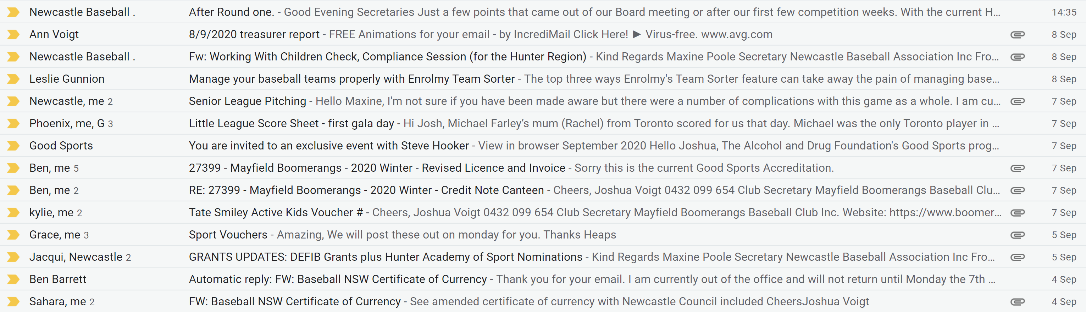
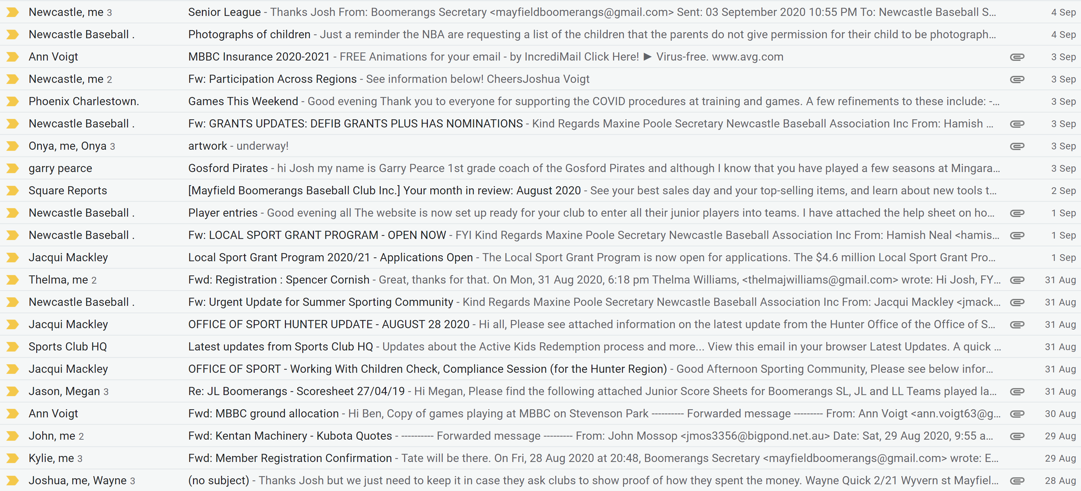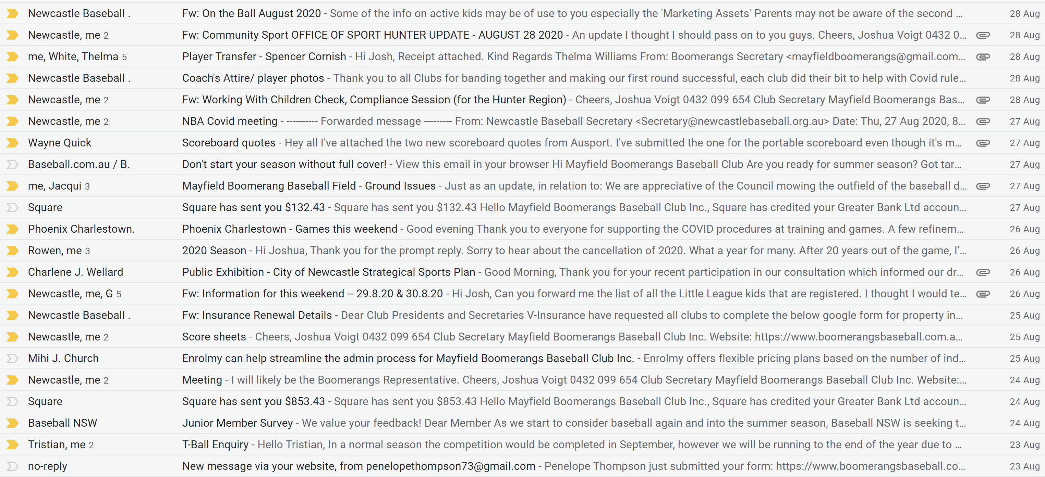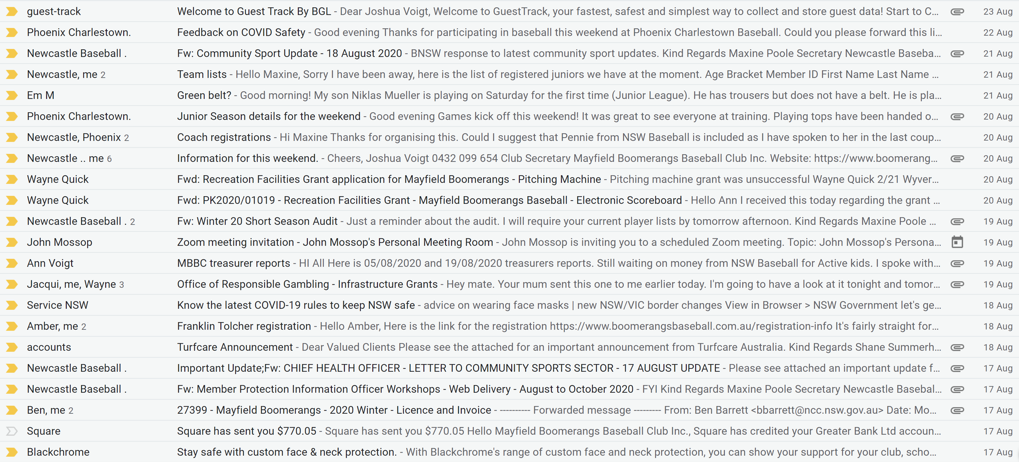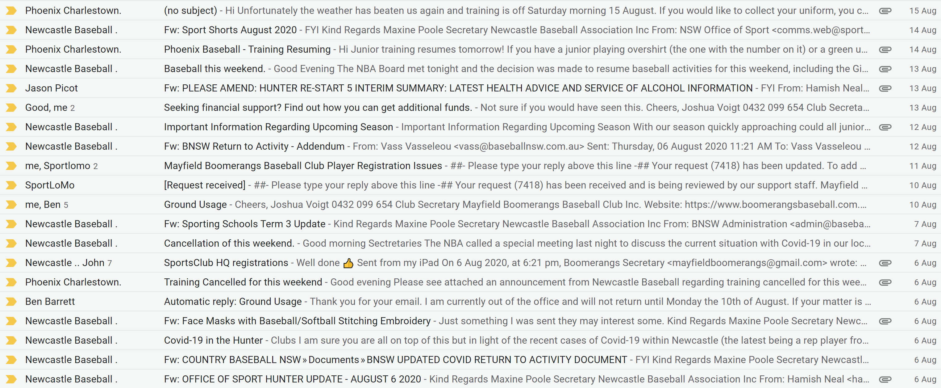

Treasurer’s Report
- Chris mentioned considering looking at putting some money into a term deposit account.
John moved the motion to contact Jason Bartlett to discuss it.
MBBC Inc. Main Account | 782236229 | MBBC Inc. Canteen Account | 72138541
Opening Balance |  | Opening Balance
Incoming |  | Incoming
Expenses |  | Expenses
Closing Balance |  | Closing Balance
MBBC Inc. Grants Account | 721808947 | Total Balance
Opening Balance |  | $38,606.63
Incoming
Expenses
Closing Balance

MBBC Inc. Main:
Expenses: |  | Incoming:

MBBC Inc. Canteen Account:
Expenses: |  | Incoming:

Grants Account:
Expenses: |  | Incoming:
Moved Ann, Seconded Josh

NBA Report
- Jason is waiting on the minutes from the NBA meeting

General Business
Jason:
- Numbers in Juniors (SL 7, JL 10, LL 9) still could recruit
- Need to look at more catcher’s gear for teams – there’s problem ordering gear.
- Coaches are all sorted
  - JL – Damien done Level 1 & 2, Mark Sinclair assisting
  - LL – Fiona and Greg Rodgers doing a good job
  - ZL/T-Ball – Ben Koystra wanted to coach his son which is in Zooka, Rich and Ben to alternate coaching age brackets (Jason to assist)
- Need to organise some sort of junior night together (maybe per team)
- Potentially need to look at doing some sort of mini canteen on the afternoon shift
- Well done to Ann getting all the juniors in club uniforms.
- Need to email all juniors regarding Photos being taken
- Draw to be released on website after this weekend.
Rich:
- Wanted to discuss the t-ball coaching scenario
- Wanted clarification on the one spectator condition – volunteers aren’t necessarily spectators.
Chris:
- Wondered why the juniors are getting elderly umpires when that was a contributing factor to the senior season being cancelled.
- Bought up looking at fundraising/sponsorship from Blackchrome (contra)
Rob:
- Wanted to know if Jason misses an NBA Board meeting can someone go in his place.
John:
- Need to look at maybe doing a roster for volunteers.
- Potential to hold an entire club zoom meeting.

Ann:
- If we can get Snuffy to get more photos for each team
- Possibly use a 2020 junior players Facebook page.
Josh – N/A

Next Meeting
??/??/2020 @ 7:00 pm @ Beauford Hotel
Motion to adjourn was made at ??:?? pm and was passed unanimously.

Action List
Task | Who | Due Date:
OLD
NEW

