Boomerangs Minutes
  - Mayfield Boomerangs Baseball Club
Date | time 15/07/2020 07:05 PM |Meeting called to order by John Mossop

In Attendance
Attendees: John Mossop (President), Jason Picot (Snr-Vice President), Joshua Voigt (Secretary), Ann Voigt (Treasurer), Stephen Petherbridge (Vice President), Virginia Petherbridge
Apologies: Wayne Quick, Chris Jordan, Robert Voigt

Approval of Minutes
The minutes from the 17/06/2020 were read and accepted.
Moved Josh, Seconded Ann

Business Arising from Previous Minutes
- Barefoot Bowls – Need to confirm with Mayfield West Bowling Club
- Mower Status – John hasn’t received an answer, will follow them up.

Correspondence
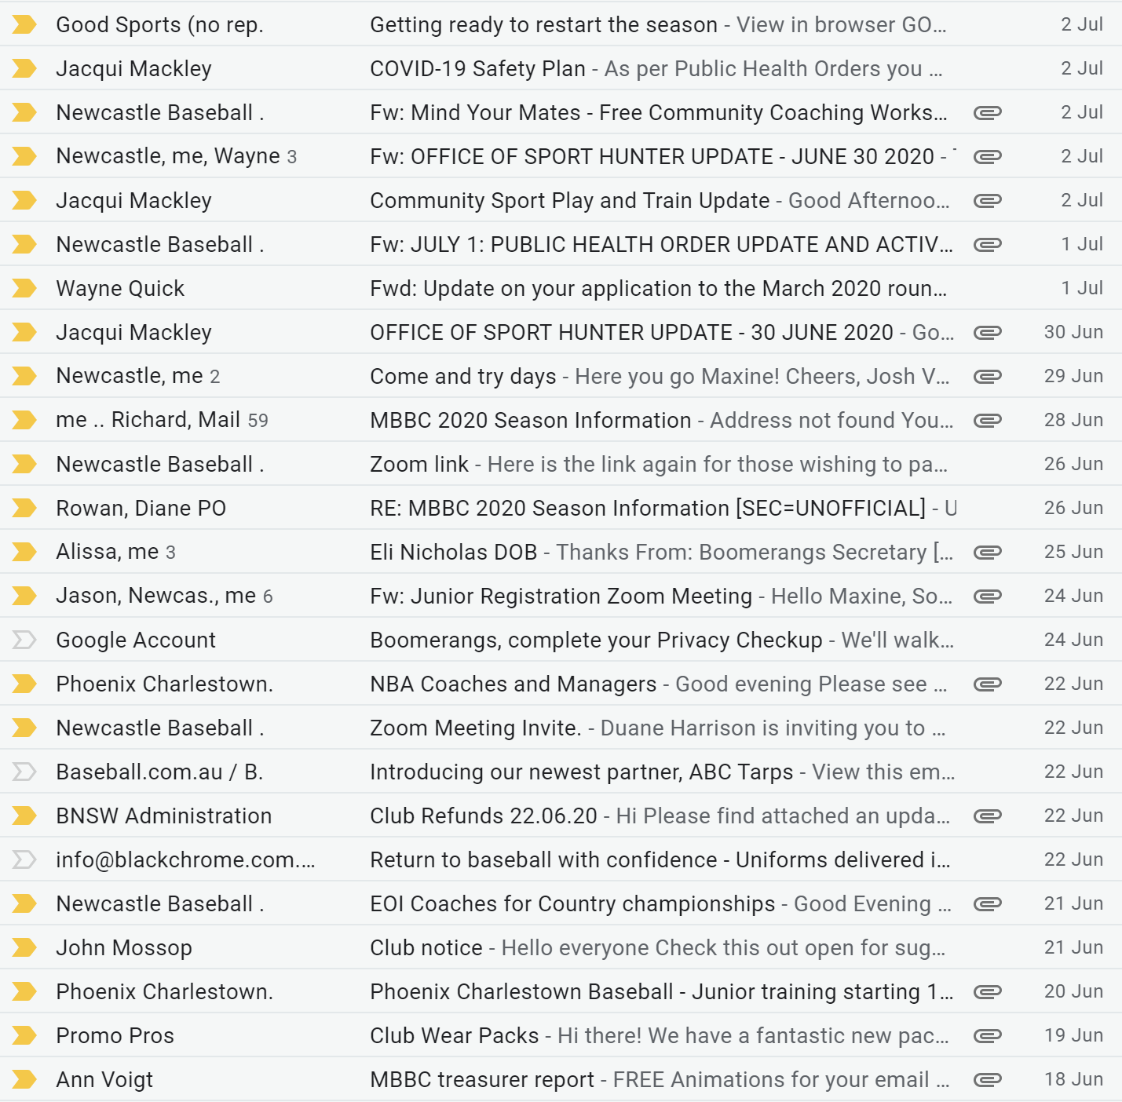

Treasurer’s Report
MBBC Inc. Main Account | 782236229 | MBBC Inc. Canteen Account | 72138541
Opening Balance | $2700.11 | Opening Balance | $5,678.88
Incoming | $190.01 | Incoming | $2,000.00
Expenses | $215.00 | Expenses
Closing Balance | $2,675.12 | Closing Balance | $7,678.88
MBBC Inc. Grants Account | 721808947 | Total Balance
Opening Balance | $25,750.87 | $36,104.87
Incoming
Expenses
Closing Balance | $25,750.87

MBBC Inc. Main:
Expenses: |  | Incoming:
Refund club fees | $215.00 | Clothing  Bank Interest | $90.00  $00.01

MBBC Inc. Canteen Account:
Expenses: |  | Incoming:
 |  | Beauford Sponsorship money | $2,000.00

Grants Account:
Expenses: |  | Incoming:
Moved Ann, Seconded Virginia

NBA Report
- T-Ball & Zooka always at Plattsburg
- Senior League & Little League
- Girls come and try day – Sunday 26th July
- Rep Trials – Sunday 26th July
- NBA looking to pay half of the ground fees for this season.
- Each club with junior teams won’t be charged per team but an outright figure.
- There’s a Covid-19 grant out currently.
- Each Club needs to work on a risk assessment for the Council/NBA/BNSW based around Covid-19.

General Business
Stephen:
- Asked about potential Raffle – Not available until Covid-19 settles down
Virginia – N/A
Jason:
- Worried about volunteer numbers for Come & Try Days.
- Drink Bottles/Coffee Mugs
Josh:
- Daniel Isaac Sponsorship
- Supplement Stop
Ann:
- Sign on Outfield Fence – possibly looking at getting a metal one made up.
John:
- Water organised for Saturday

Next Meeting
05/08/2020 @ 7:00 pm @ Beauford Hotel
Motion to adjourn was made at 08:00 pm and was passed unanimously.

Action List
Task | Who | Due Date | Priority
New
Chase up Barefoot Bowls night @ Mayfield West | Josh/Ann | Next meeting | Low
Chase up ride on mower and push mower | John | ASAP | Moderate
Risk assessment for the Council/NBA/BNSW | Josh | ASAP | High
Investigate Coffee Mugs/Drink Bottles | Jason | Next meeting | Low

