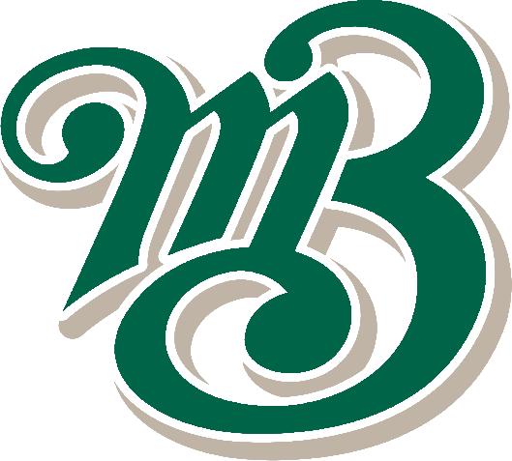
Boomerangs Minutes
  - Mayfield Boomerangs Baseball Club
Date | time 17/06/2020 7:00 PM |Meeting called to order by John Mossop

In Attendance
Attendees: John Mossop (President), Jason Picot (Snr-Vice President), Joshua Voigt (Secretary), Ann Voigt (Treasurer), Stephen Petherbridge (Vice President), Virginia Petherbridge
Apologies: Chris Jordan, Robert Voigt

Approval of Minutes
During the quarantine, the zoom meetings minutes weren’t recorded.

Business Arising from Previous Minutes
- N/A

Correspondence
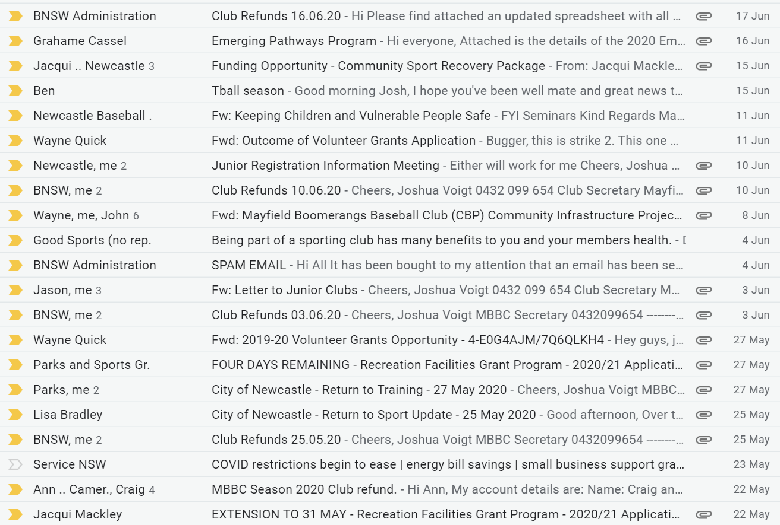
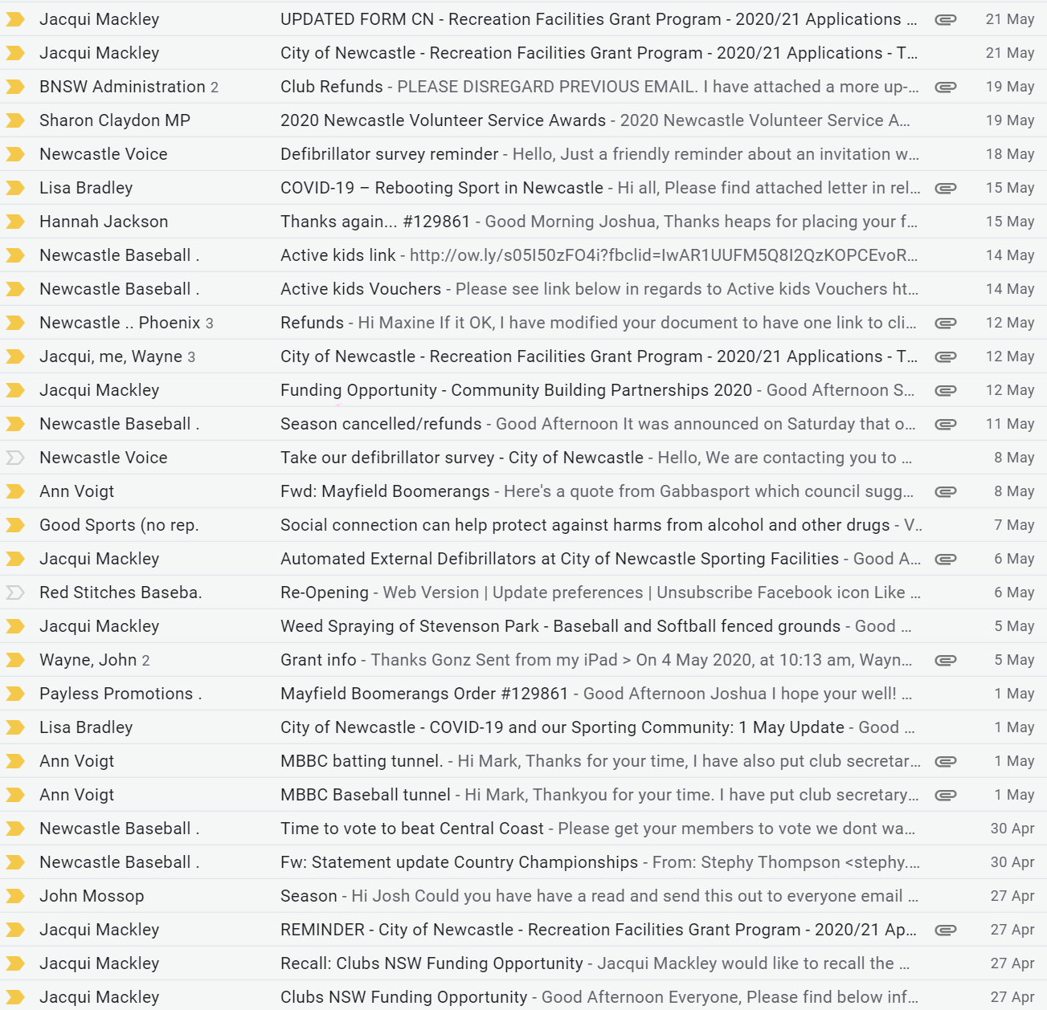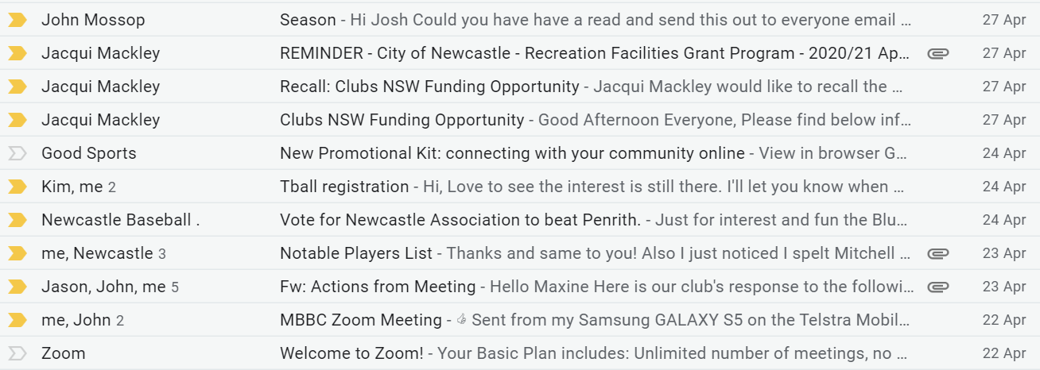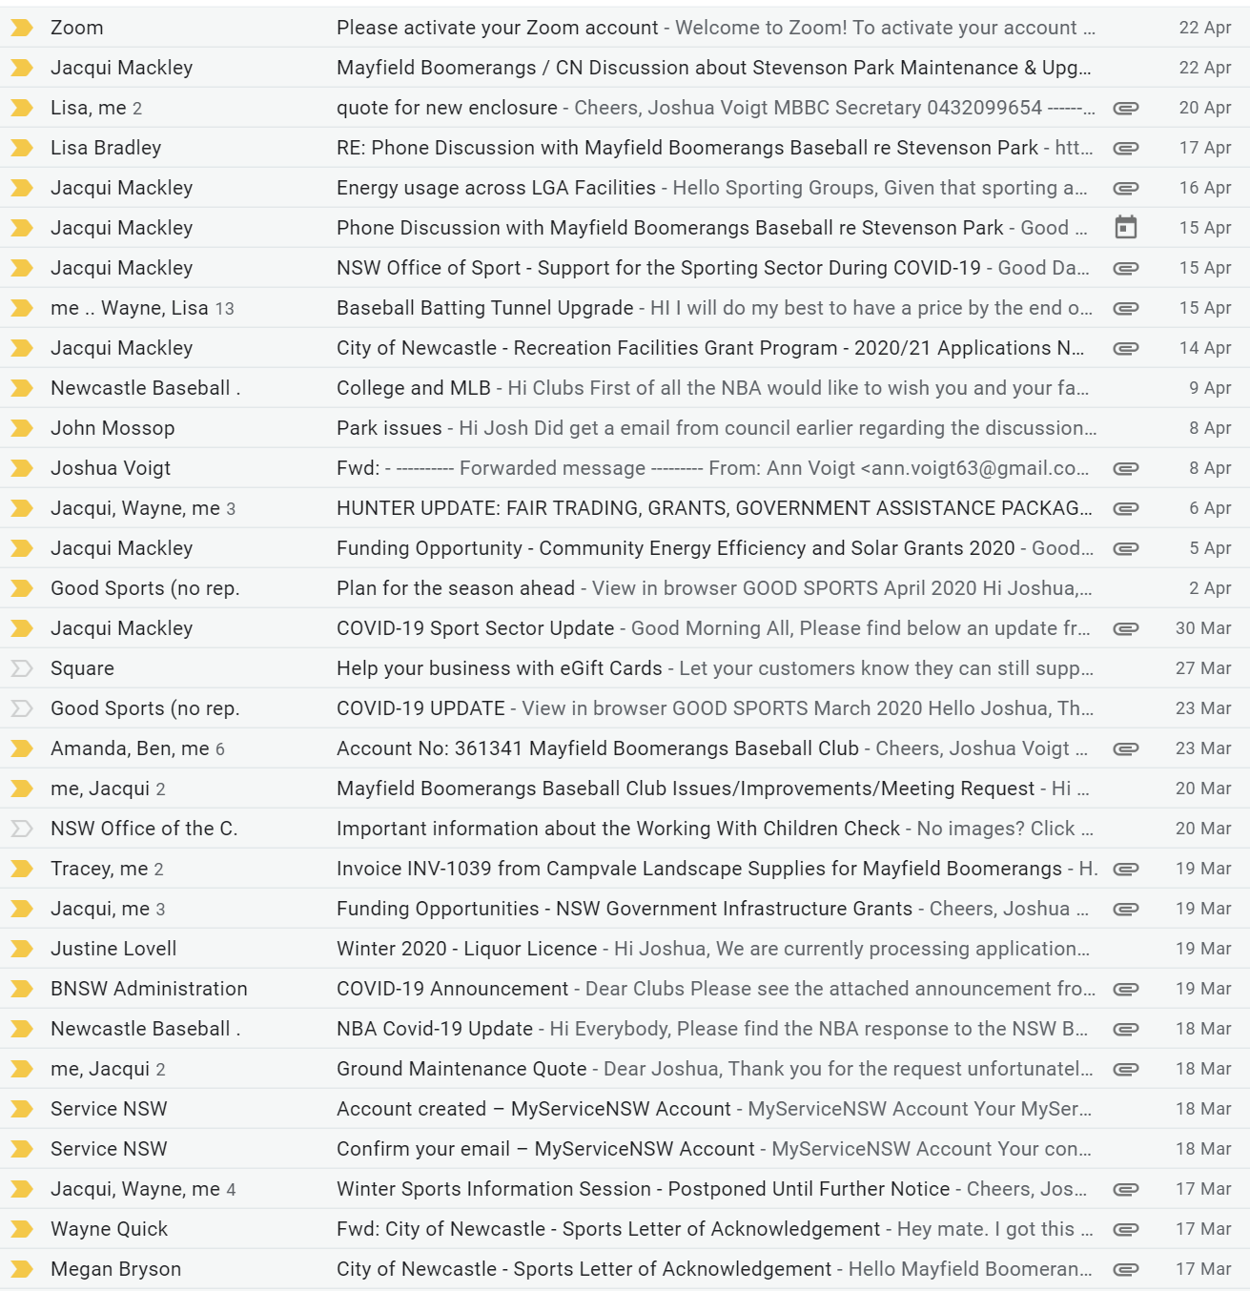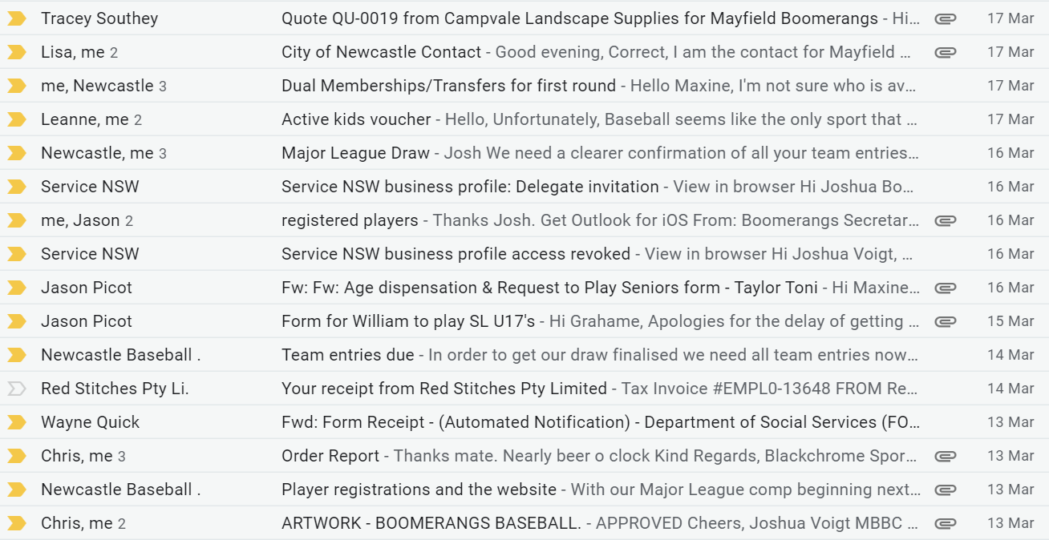

Treasurer’s Report

MBBC Inc. Main Account | 782236229 | MBBC Inc. Canteen Account | 72138541
Opening Balance | $5195.49 | Opening Balance | $7185.88
Incoming | $1544.00 | Incoming
Expenses | $4039.38 | Expenses | $1507.00
Closing Balance | $2700.11 | Closing Balance | $5678.88
MBBC Inc. Grants Account | 721808947 | Total Balance
Opening Balance | $31,653.83 | $34,129.86
Incoming
Expenses | $5902.96
Closing Balance | $25,750.87

MBBC Inc. Main:
Expenses: |  | Incoming:
Bunnings  NOC  Refund players Club fees  Refund Active Kid  Bunnings (diesel can)  Petrol/Diesel  Service NSW | $28.50  $303.20  $3415.00  $100.00  $44.89  $64.79  $83.00 | Sports Club  Raffle  Services NSW  Players Hat | $560.00  $49.00  $900.00  $35.00

MBBC Inc. Canteen Account:
Expenses: |  | Incoming:
Indico Pty Ltd (shorts) | $1507.00

Grants Account:
Expenses: |  | Incoming:
Red Stitches  Indico Pty Ltd (t/Shirts) | $1010.71  $4892.25
Moved Ann, Seconded Josh

NBA Report
- Come & try days start 18th July
- Season kick off 22nd/23rd August & season finish 13th December
- NBA supporting the Country Championships (Illawarra)
- NBA to focus on 18s/16s/14s age groups for country champs.
- NBA to get signs/flyers from Triton Signs and look to into Facebook marketing.
- Players from the central coast could be affected.
- Game Days/Times – See additional Document
- NBA to run a high-performance program at Windsor.
- Letter from the Chairman need to send to juniors.

General Business
Wayne:
- Got a no back on 2 grants
- Talking to a Grant person and has been informed that with money in the bank we won’t win
- The Council won’t support the batting tunnel application just from Boomerangs. Need to approach NBA and NDSA for a combined application.
Stephen – N/A
Virginia – N/A
Ann:
- Got the Shorts/Undershirts on Monday – available for sale ($20 for undershirts/$25 shorts/$45 combo)
- Spoke with Mayfield West Bowling Club,
  - Let them know we were happy to have a trivia night asap (waiting for the restrictions to lift)
  - Potential to have a barefoot bowls night (20 people on the greens atm)
- The SPLC mower is out of service – John has chased up information on the mower and looking to get someone to come look at it.
- Spoke with John Redmond (Council person responsible on mowing Stevenson Park) – they will be mowing the outfield with the smaller mower.
- Need to contact Lisa about the broken Canteen gate.
- Got a text from Jethro about the lights at the park being changed to on/off switches rather than token-based timers. (Will be returning them to the council)
Jason:
- Life Members to get a training shirt.
- Wants to start organising the Junior season happening
- Need to talk to Joel about getting some flyers made up.
- Need more social events – trivia night/wine trip/barefoot bowls.
Josh:
- Barefoot Bowls
- Steve Harris – Warner’s at the Bay
- Supporters Tour
John:
- Notice to everyone about things starting up and that we need help with junior recruitment and volunteers. To talk about

Next Meeting
15/07/2020 @ 7:00 pm @ Beauford Hotel

